PRESS KIT
Prepared exclusively for
First Run Features

BILL W.
Conscious Contact
An Award-Winning Documentary Film

Jay Stinnett | Film Producer & Author
Muse Bookings LLC
info@billwconsciouscontact.com | 310-874-2341

FILM OVERVIEW

Bill W.: Conscious Contact is an award-winning feature documentary exploring the spiritual life of William Griffith Wilson — co-founder of Alcoholics Anonymous and one of the most influential figures of the twentieth century. Drawing on 25 years of original biographical research by producer Jay Stinnett, the film examines the antecedents of the Twelve Step Movement and the profound spiritual philosophy at its core.

The film features rare archival images from the collection of The Stepping Stones Foundation — the historic home of Bill and Lois Wilson in Katonah, New York — along with interviews with leading scholars and writers in the field of recovery history. Bill W.: Conscious Contact has screened internationally, including in India, Dubai, England, Germany, and Austria, and sold out three self-produced theatrical events in Arizona prior to formal distribution.

"Bill Wilson is one of the most fascinating people that lived in the 20th century — on many levels, he's the most important person. He's significant to so many millions of people because of what he did in his life — authored Alcoholics Anonymous."
— William H. Schaberg, Author, Writing the Big Book: The Creation of A.A.

FILM STILLS & ARCHIVAL IMAGES

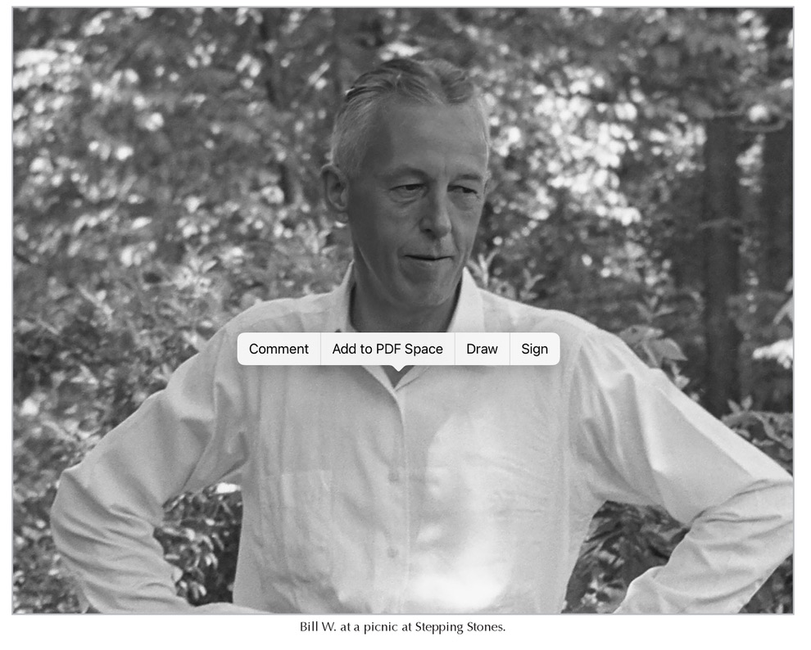
Bill W. at a picnic at Stepping Stones, Katonah, New York. Photo courtesy The Stepping Stones Foundation.

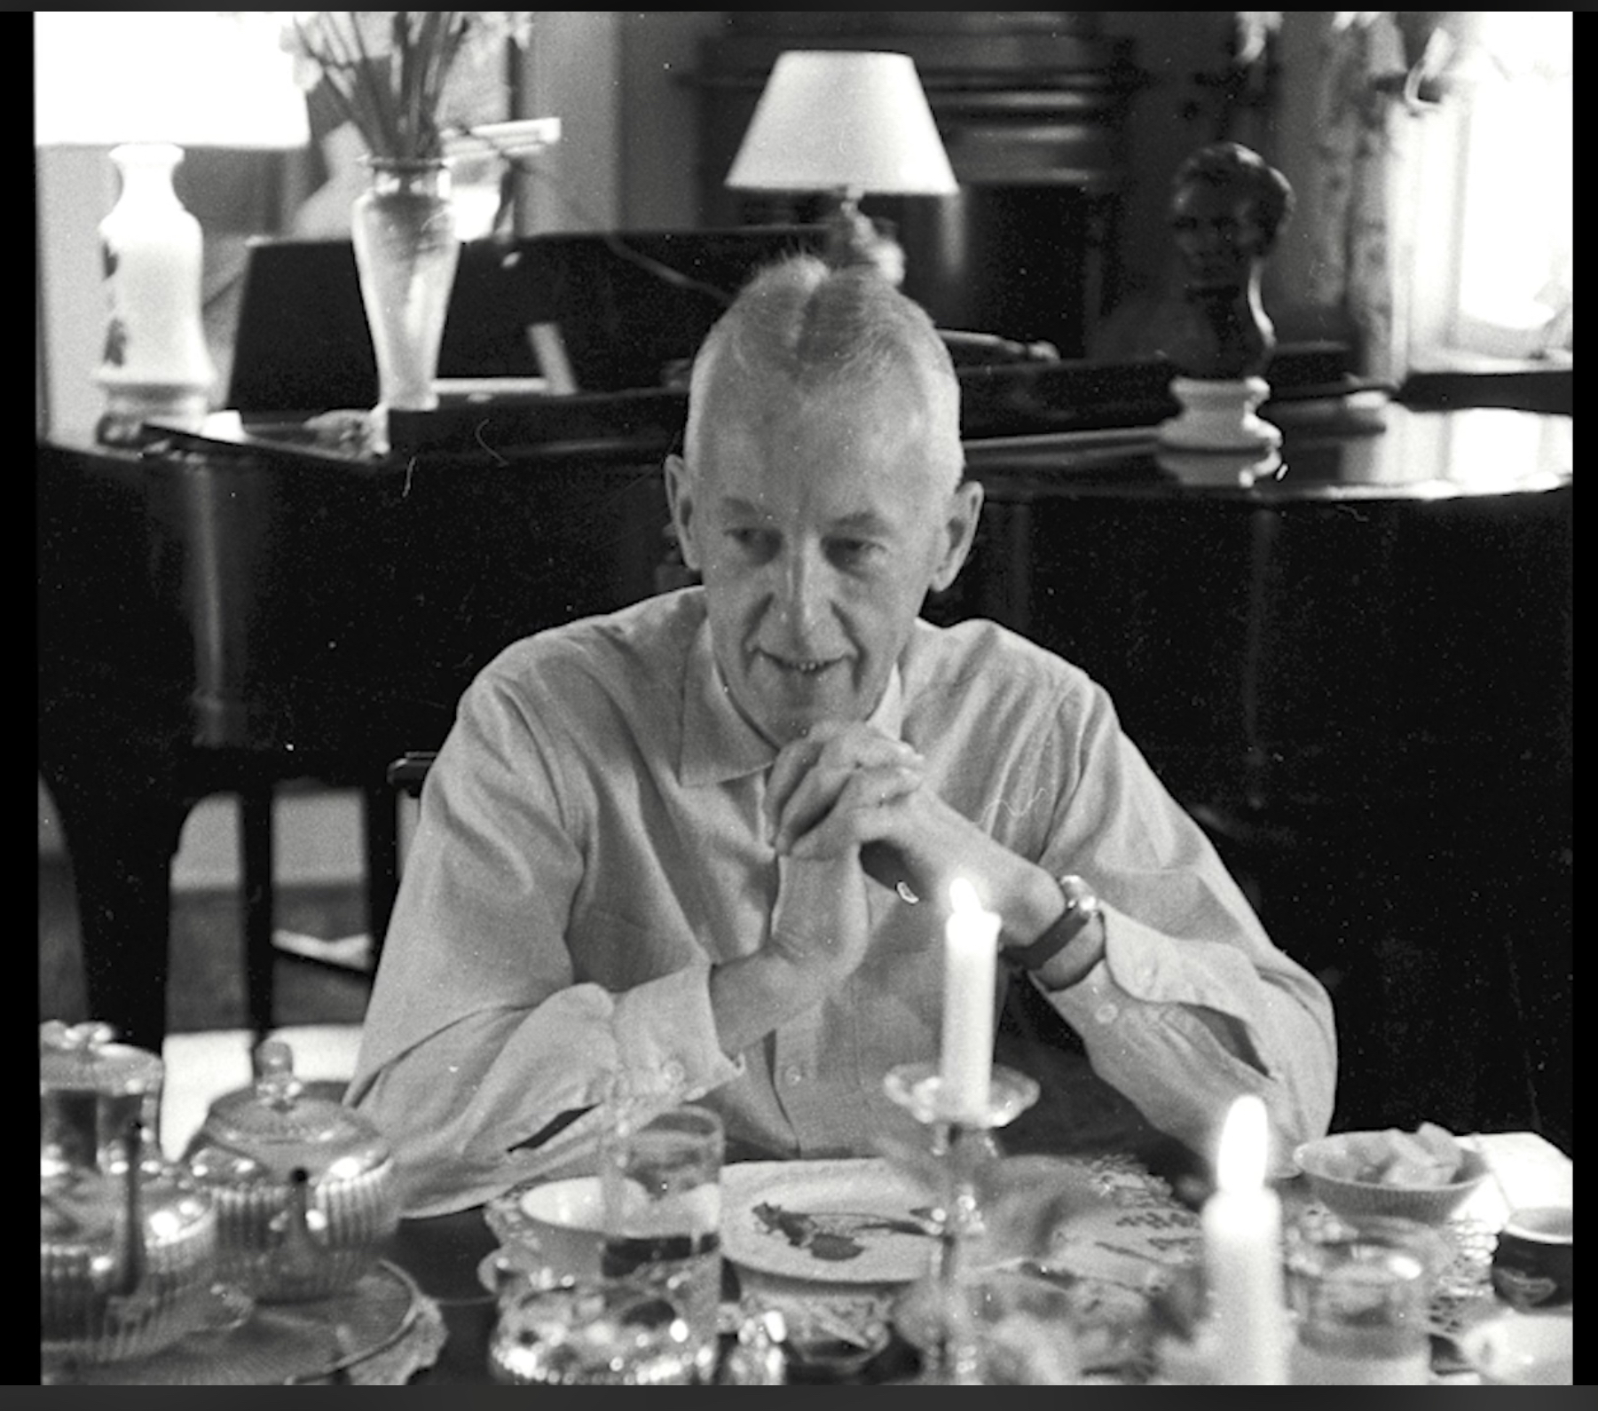
Bill Wilson at dinner. Photo courtesy The Stepping Stones Foundation.
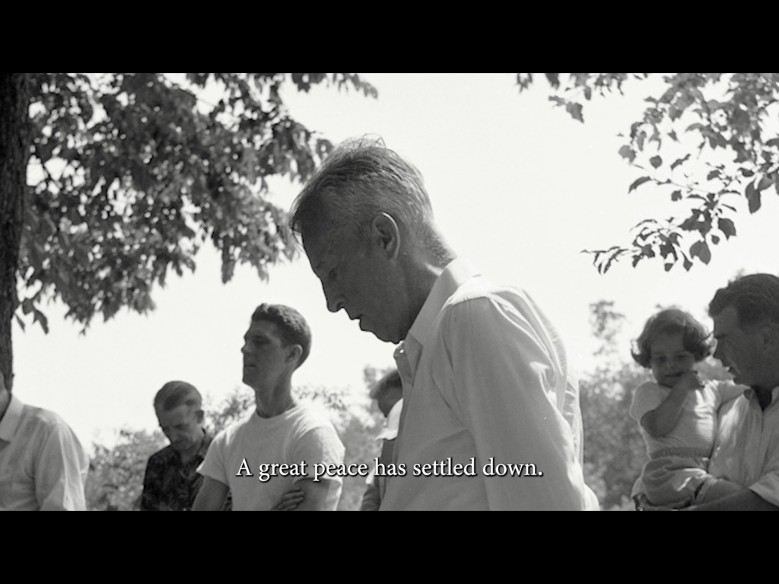
Film still: "A great peace has settled down." — Bill Wilson

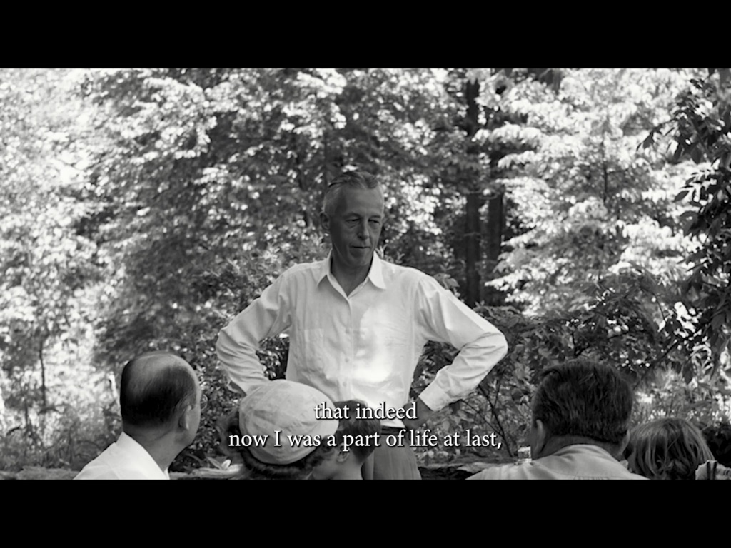
Film still: "...that indeed now I was a part of life at last." — Bill Wilson

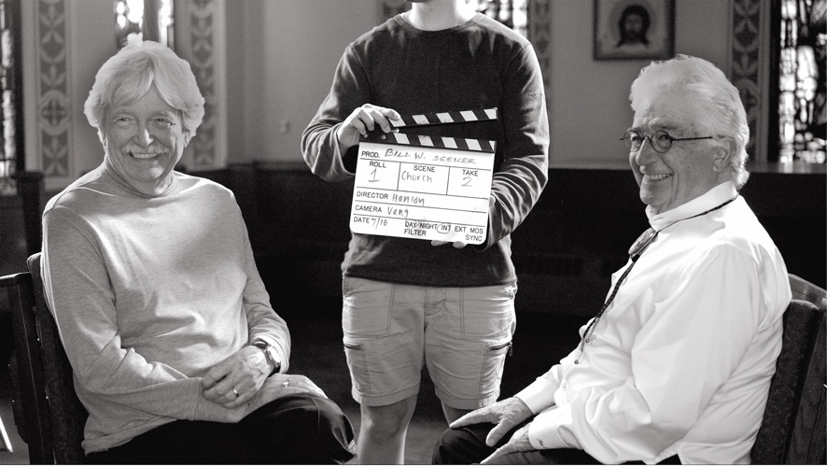
On set: Director Kevin Hanlon (right) during production of Bill W.: Conscious Contact.
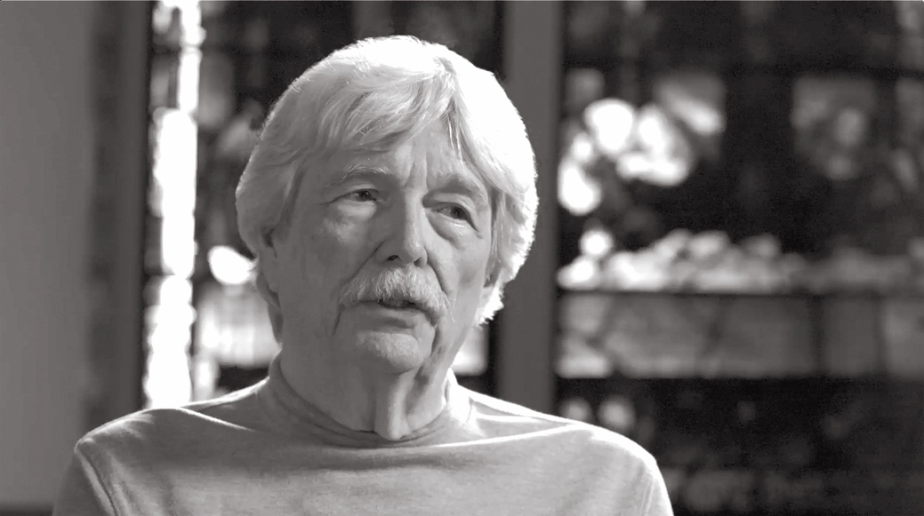
William H. Schaberg, Author, Writing the Big Book: The Creation of A.A. — featured interview subject.

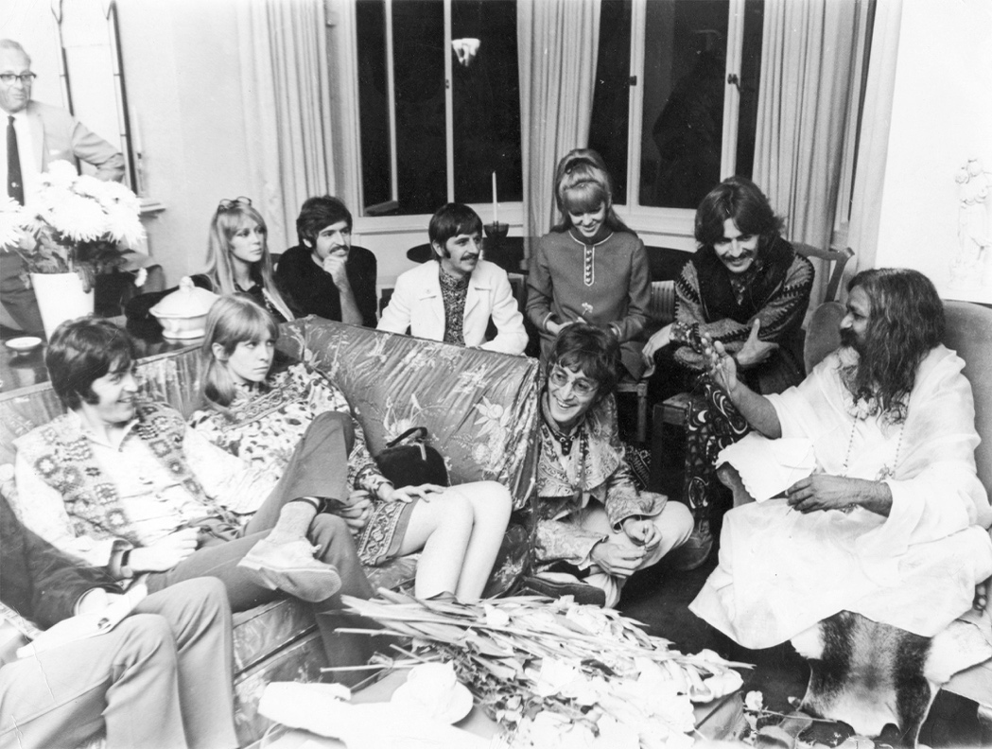
The Beatles with Maharishi Mahesh Yogi, London — the spiritual awakening movement that shaped an era.

SYNOPSIS

Short Synopsis
Bill W.: Conscious Contact is an award-winning documentary exploring the spiritual life of Bill Wilson, co-founder of Alcoholics Anonymous. Drawing on 25 years of biographical research, the film reveals the 10 most remarkable characteristics of Wilson's personal philosophy — and the profound spiritual traditions that shaped the Twelve Step Movement. Produced in joint venture with The Stepping Stones Foundation.
Long Synopsis
Who was Bill Wilson beyond the founding of Alcoholics Anonymous? Bill W.: Conscious Contact sets out to answer that question — and in doing so, illuminates the spiritual foundations of one of the most influential movements of the twentieth century.

Producer and independent scholar Jay Stinnett brings 25 years of original biographical research to this feature documentary, tracing the arc of Wilson's inner life: his experiences with spiritual awakening, his exploration of consciousness and mystical experience, and the philosophical principles he distilled into the Twelve Steps — principles that would go on to transform the lives of millions around the world.

Featuring rare archival photography from The Stepping Stones Foundation — the historic home of Bill and Lois Wilson in Katonah, New York — as well as interviews with leading scholars in recovery history, the film presents a portrait of Wilson as one of the great spiritual thinkers of the American twentieth century.

Bill W.: Conscious Contact has screened internationally and is presented in joint venture with The Stepping Stones Foundation. It is directed by Kevin Hanlon.

AWARDS & RECOGNITION

Bill W.: Conscious Contact has received recognition at film festivals and competitions across the United States and internationally, earning ten awards:

- Best Documentary Feature — Illuminate Film Festival
- Best Spiritual Documentary — Beverly Hills Film Festival
- Best Documentary — Sedona International Film Festival
- Best Director, Documentary — Awareness Film Festival
- Best Cinematography, Documentary — Awareness Film Festival
- Audience Choice Award — Awareness Film Festival
- Best Documentary — International Christian Film Festival
- Silver Award, Documentary — IndieFEST Film Awards
- Award of Merit, Documentary — IndieFEST Film Awards
- Communicator Award of Excellence — Documentary

The film has screened internationally in India, Dubai, England, Germany, and Austria, and sold out three self-produced theatrical events in Arizona prior to formal distribution.

ABOUT THE FILMMAKER

Jay Stinnett — Producer & Author
Jay Stinnett is an independent scholar, biographer, documentary producer, and author based in Sedona, Arizona. He operates through Muse Bookings LLC and has devoted 25 years to biographical research into the life and spiritual philosophy of Bill Wilson, co-founder of Alcoholics Anonymous.

His feature documentary Bill W.: Conscious Contact — produced in joint venture with The Stepping Stones Foundation in Katonah, New York, and directed by Kevin Hanlon — has earned ten awards at film festivals across the United States and has screened internationally in India, Dubai, England, Germany, and Austria. The film has sold out multiple self-produced theatrical events and has been acquired for distribution by First Run Features, covering Kanopy educational streaming, North American TVOD, and TV/broadcast rights.

A companion volume — Bill W.: Conscious Contact: The Award-Winning Film on Paper — is published through BookBaby and IngramSpark. The 144-page pictorial hardcover features rare archival images from The Stepping Stones Foundation collection, the complete film transcript, and a distillation of the 10 most remarkable characteristics of Bill Wilson's personal philosophy drawn from Stinnett's decades of research.

Stinnett is a keynote speaker at international conferences on recovery history and spirituality, including an upcoming engagement in Japan in October 2026. He is currently developing a direct subscription platform to house the film, companion book, and weekly original content.

Kevin Hanlon — Director
Kevin Hanlon is an award-winning documentary filmmaker and the director of Bill W.: Conscious Contact. His work on the film earned a Best Director, Documentary award at the Awareness Film Festival, among the project's ten total awards.

COMPANION PUBLICATION

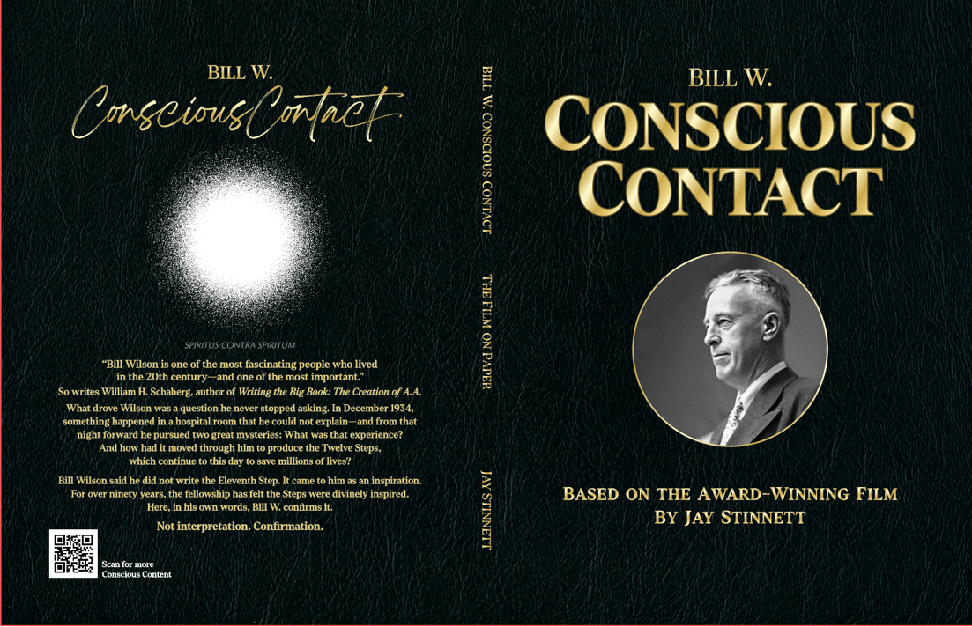

A companion volume to the film is now available:

Bill W.: Conscious Contact — The Award-Winning Film on Paper
By Jay Stinnett | Published by Muse Bookings LLC / BookBaby
This 8.5" x 11", 144-page pictorial history is printed on premium paper with the highest quality photo reproduction available. It contains many of the glorious archival images from the Stepping Stones Foundation collection featured in the film, the complete film transcript, and a distillation of the 10 most remarkable characteristics of Bill Wilson's personal philosophy drawn from Jay Stinnett's 25 years of biographical research.

Retail Price: $39.95 | Paperback
Distribution: Amazon, IngramSpark, and direct via Muse Bookings LLC
Publication Launch: American Library Association Conference, Chicago

CONTACT INFORMATION

JAY STINNETT
Film Producer & Author
Muse Bookings LLC
info@billwconsciouscontact.com
310-874-2341

Produced in joint venture with
The Stepping Stones Foundation
Katonah, New York

www.billwconsciouscontact.com

